# Subscription Reports

​This report provides all kinds of details that enable you to keep track of customer retention.

* Signups
* Activation
* Active Customers
* Net Cancellations
* Renewals
* Subscription Summary
* Activations by country
* Subscription cancellation due to payment failure

#### Signups

Number of customers who have signed up including the users who are in trial. ​Customers may or may not switch to a paid plan. The number of sign ups gives you the number of people using your product.

#### Activation

Number of customers who have paid for the product in the selected time frame. In other words, number of activations can be looked at as the number of first payments received from the customer in the selected duration.

This includes 2 cases.

* Customers upgrading from trial to a paid plan.
* New customers directly signing up for a paid plan.

​If 4 customers upgraded to a paid plan and 2 new customers signed up directly for a paid plan in a day, the number of activation for that day would be 6.​

#### Active Customers

Number of customers subscribed to a paid plan till date. This does not include customers who are in trial.

Consider that there are 20 active customers. If 5 customers have upgraded to a paid plan and 3 customers have canceled their subscriptions, the number of active customers would be 22.

#### Net cancellations

This includes the number of cancellations with the number of reactivations of plans deducted.

Net cancellations = Number of cancellations in a day - Number of reactivations in the same day.

You can also find three tables below the Net Cancellations graph.

* The first table lists the plans and their cancellation count letting you find out which plan was canceled the most.
* The second table lets you understand which customer had canceled which plan and when.
* The third table provides details regarding customers who have reactivated their subscriptions including the ​canceled plan and the plan that they are currently in.

#### Renewals

Number of subscriptions that get renewed in the selected time duration. This will also include the renewal invoices charged due to dunning.

You can also find two tables under the “Renewals” graph.

* The first table gives you the details of the plan renewed and the number of times it was renewed.
* The second tables provides details regarding which customer has renewed which plan and when.

#### Subscription Summary

Subscription summary involves a tabular view of Signups, Activations, Cancellations, Reactivations and Active Customers on a particular ​day or month.

Subscriptions Details displays everything we need to know about a subscription. This includes status of the subscription, name of the customer involved, their email address, cost of the subscription and the plan subscribed.

The date on which the subscription was created, when it was last billed and the next billing date is also displayed.

#### Activations by Country

Number of paid subscriptions in a country for a selected duration of time.

#### Subscription cancellation due to payment failure

This report displays the details of subscriptions that are canceled after dunning (sufficient retries are made to charge the customer’s card)

# Transaction Reports

This report provides details of all transactions including invoices, credit note, payment details, payment failures, refund details and card expiry.

* Invoice Details
* Payment Details
* Payment Failures
* Refund Details
* Card Expiry

#### Invoice details

This provides a tabular view of invoice details like Status, Invoice number, Invoice Date, Customer Name, Customer Email, Invoice Amount and Balance.

#### Credit Note details

This provides a tabular view of credit note details like Status, Credit Note number, Date, Customer Name, Customer Email, Credit Note Amount and Balance.

#### Payment Details

This provides a tabular view of Payment ID, Invoice Number, Payment Date, Customer Name, Email, Type, last four digits of the customer’s card, the gateway transaction ID involved in the transaction and amount paid.

#### Payment Failures

This includes a graph depicting the number of payment failures caused when renewing a plan.

A tabular view consisting of the customer name, the plan for which the renewal attempt was made, the last four digits of the card number and transaction details. The transaction details includes the details of why the transaction had failed.

#### Refund Details

This provides a tabular view of refund details namely the date when the refund was made, the reference number used for the refund, the name of the customer to whom the refund was made, customer’s email, the refund mode and the amount refund. Learn more.

#### Card Expiry

This report provides the details of customers whose cards are about to expire as well as those whose cards have already expired.

**Cards about to expire** - You can find out the cards which are about to expire at a specified month/year. For instance, you can find out the cards expiring on July 2015.

**Expired Cards** - You can find out the list of all expired cards by selecting “Expired” as the status.

# Sales Reports

A sales report in FIN subscriptions shows your organization’s actual sales by plans.

* Sales by Plan

#### Sales by Plan

This report will give you a comprehensive statistics of the plans’ sold count and total sales.

To generate this report,

* Navigate to **Reports** section and click on **Sales > Sales by Plan**.

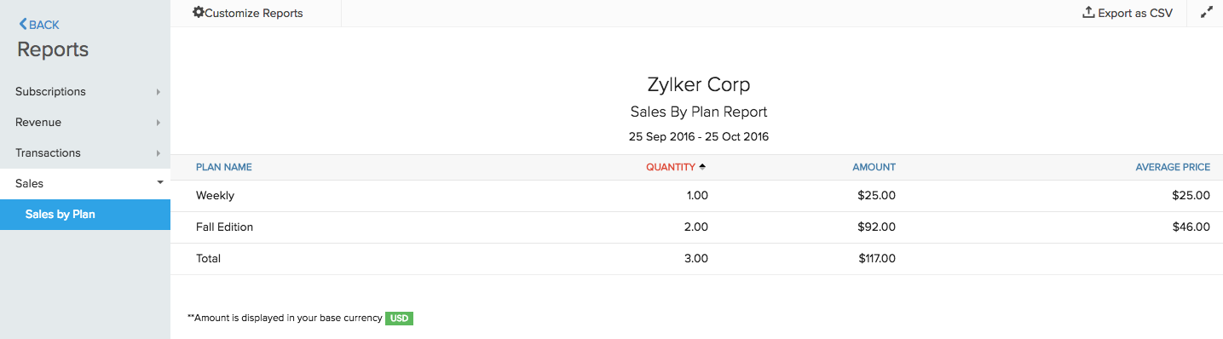

You can also click on the respective plan to get detailed customer informations who has subscribed to the plan.

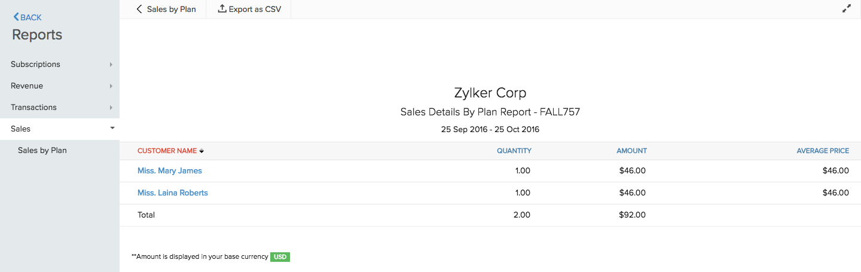

# Activity Reports

Activity Reports allows you to monitor the organization activities in the most simple yet efficient way possible.

* API Usage

#### API Usage

This report allows you to keep track of the organization API usage. You can also track the API calls made by different organization users (if you have any) and the IP address the API was called from.

As of now, you can only track API call made in a day. This report will be reset automatically every midnight.

To generate the API usage report,

* Navigate to **Reports** section and click on **Activity > API usage**.

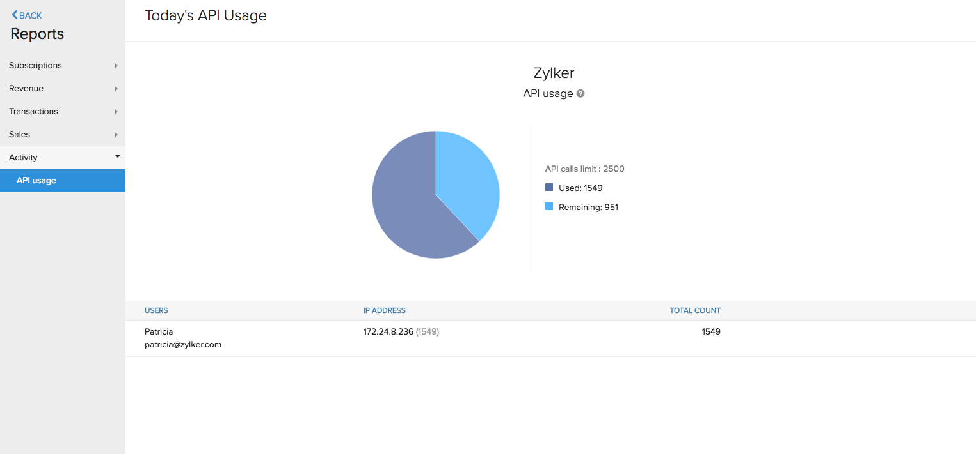

**Note:** The API calls limit will depend on the pricing plan you’ve subscribed to. For instance, Standard plan has a limit of 1000 api calls/day and Professional plan has a limit of 2500 api calls/day.